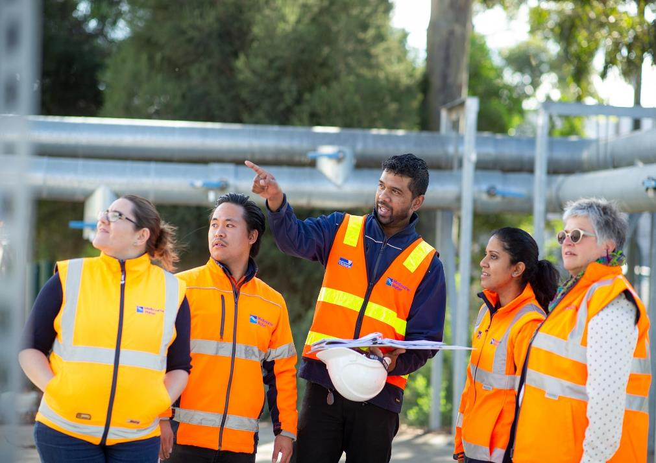

Diversity and Inclusion Strategy 2020–2025

Empowering Melbourne Water to grow
a diverse workforce and inclusive
workplace culture

March 2020

Table of contents
From the Managing Director 3
Introduction 4
Our approach to Diversity and Inclusion 7
Strategic alignment 8
Achievements to date 9
The 2020–2025 Diversity and Inclusion Strategy 11
Strategic Framework 12
Diversity and Inclusion Strategy Objectives and Outcomes 14
From Vision to Action – implementing the strategy 22
Implementation Approach and Governance Framework 22
Appendix 24
Legislative and policy requirements 24
Melbourne Water’s Approach to Diversity and Inclusion 25
Melbourne Water’s Diversity and Inclusion Journey 26
Methodology 30
Future trends 33
References 34

Message from the Managing Director
Melbourne Water and its employees are committed to growing the diversity of our workforce and fostering an inclusive workplace culture. We recognise that actively creating and supporting diversity and inclusion not only enables us to attract, retain and develop diverse talent, it also contributes to a safer and more engaged workforce, increases our capacity for high performance, and enables us to better understand and respond to the needs of the community we serve. This enables Melbourne Water to contribute to a more inclusive, equitable, fair and just society and achieve our vision of enhancing life and liveability.
Melbourne Water is committed to valuing and supporting individual differences and creating an environment where everyone can fully contribute to realise their full potential. We will continue to work hard to foster an organisation that genuinely supports inclusion, embraces different perspectives, and supports all people to achieve fulfilling careers and lives.
The diverse experiences, approaches and perspectives of our people empower Melbourne Water to effectively respond to our changing work and environment, meet challenges, solve complex issues, and deliver innovative solutions for our community. A diverse workforce supports us to understand the needs of our diverse community and continually improve customer and community outcomes.
This Diversity and Inclusion Strategy (2020–2025) reflects a maturing approach to Diversity and Inclusion for Melbourne Water in two ways: it expands our focus areas to include culturally and linguistically diverse and socially disadvantaged communities, and advances us further towards adopting a holistic approach that influences our work both internally and externally, embedding diversity and inclusion in all that we do. Applying a diversity and inclusion lens to our external work will influence procurement decisions, the preparation of information we provide to customers, how and who we seek to consult with on new programs of work, and how we plan and prioritise works to encourage community use of green spaces and waterways.

Michael Wandmaker
Managing Director
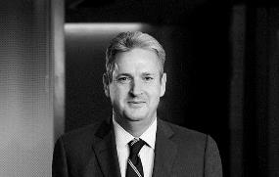

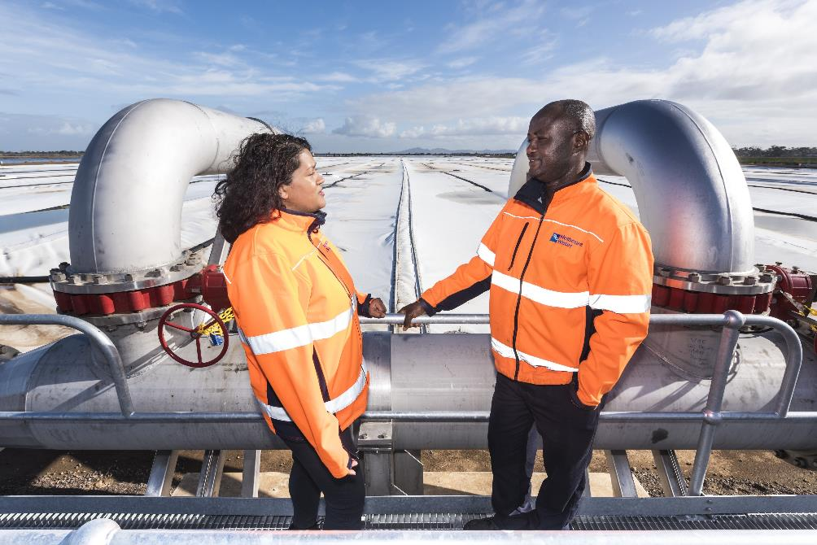

Introduction
Melbourne Water has made strong strides to creating a more diverse and inclusive organisation through the delivery of our first Diversity and Inclusion Strategy (2016–2020), particularly regarding increased demographic diversity and a culture that embraces flexible working.
This Diversity and Inclusion Strategy (2020–2025) builds upon previous initiatives and strengthens our commitment to both creating a more diverse and inclusive organisation, and to embedding and integrating diversity and inclusion into everything we do, from our relationships with suppliers and stakeholders to how we deliver services for our community and customers.
It will deliver a more diverse and inclusive Melbourne Water through influencing how we attract, retain and develop our people, fostering a flexible and inclusive culture, and through ensuring diversity and inclusion is integrated into how we engage with and provide services to our community.
A robust approach to implementation, reporting, and governance will ensure accountability for delivery against our targets and objectives, which in turn will influence the development of implementation plans and Key Performance Indicators that will enable delivery of this strategy. This Diversity and Inclusion Strategy (2020–2025) is viewed as a key enabler to delivering Melbourne Water’s People & Capability Strategy, and to support delivery against Melbourne Water’s ultimate goal of enhancing life and liveability.

Melbourne Water’s commitment to Diversity and Inclusion
Melbourne Water has a strong commitment to Diversity and Inclusion not only within our own organisation and supply chain, but also within the larger system that constitutes our environment. Adopting a holistic or ‘ecosystem’ approach, we aim to integrate and embed diversity and inclusion into everything we do, both internally and externally. This approach enables us to access untapped talent pools, develop our people, and foster a high-performing and engaged workforce that understands the needs of our diverse community. A diverse workforce and inclusive culture enable us to innovate, effectively problem-solve, and make robust customer-focussed decisions.
Our commitment to diversity and inclusion stems from our deeper commitment to human rights and equity. A continued focus on diversity and inclusion also ensures we meet and exceed our community’s expectations.
Our commitment to diversity and inclusion ensures our people:
- Feel valued, safe, and respected for who they are
- Have a sense of belonging and feel connected to their co-workers and community
- Have equitable access to opportunities to progress their career and develop
- Are empowered to contribute and achieve their full potential
In addition, our commitment extends to integrating and embedding diversity and inclusion in all that we do, including when planning and delivering projects and in providing services to the community.

What do we mean by Diversity and Inclusion?
Diversity refers to points of difference, including cultural background, ethnicity and race, religion, nationality, sexual orientation, work experience, socio-economic status, age, profession, ability, education, profession, gender identity, caring responsibilities, and more.
Inclusion is about embracing, celebrating and capitalising on our differences. In practice, it’s about respectfully listening, inviting others’ ideas and contributions, sharing our knowledge and experiences, and learning from each other. An inclusive work environment is one where everyone feels valued, and where everyone can access opportunities and development.

Achieving an inclusive workplace culture
An inclusive workplace culture refers to an environment which values diversity and enables people to be their authentic self in the workplace. Inclusion occurs when a diversity of people are respected, connected, progressing and contributing to organisational success. An inclusive workplace is characterised by openness, equality, respect, and non-discrimination. Inclusion is the enabler of diversity in that it provides the environment for our people to give their best and reach their full potential. In an inclusive culture, different perspectives are actively encouraged, and people are confident in their ability to progress within the organisation regardless of their particular background or identity. There is a high level of psychological safety within an inclusive organisation.
Diversity and Inclusion is integral to how we attract, retain, develop and engage people and the way we interact with each other and the community. Inclusive workplaces are crucial for our wellbeing and for minimising risk.

The benefits of Diversity
Research over the last 20 years has provided strong support for the business benefits of workforce diversity, which suggests that organisations with a diverse workforce and inclusive culture have higher levels of engagement, job satisfaction, innovation, understanding of customers’ needs, reduced turnover and improved business performance. Organisations’ diversity initiatives have a positive relationship with employee engagement, not only for diverse groups, but also for the majority group; however, this relationship only exists when the group perceives there is a high level of inclusion.
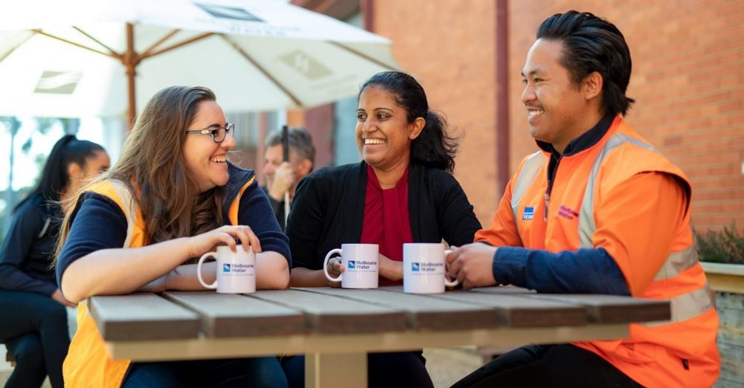
Melbourne Water’s generative safety culture is critical to our work.
Employees experience positive psychological outcomes in a work environment characterised by fair and supportive procedures, practices and policies. Although feelings of inclusion differ from person to person, perceptions of fairness and respect, and value and belonging, are two key indicators which pave the way for experiences of psychological safety and inspired performance.
Recent research suggests that there are four key enablers to diversity of thinking within organisations: demographic/functional diversity (for example, gender, race, roles and education), the mental frameworks individuals adopt to solve problems, awareness and management of unconscious biases, and inclusive leadership.

Legislative requirements
Delivery of the Diversity and Inclusion Strategy (2020–2025) contributes to Melbourne Water meeting and exceeding our legislative obligations, including: the Equal Opportunity Act (2010), the Disability Discrimination Act (1992), the Gender Equality Act (Victoria, 2020), the Sex Discrimination Act (1984), the Racial and Religious Tolerance Act (2001), the Race Discrimination Act (1975), the Age Discrimination Act (2004), the Fair Work Act (2009), and the Occupational Health and Safety Act (2004). (See the appendix for further detail on relevant legislation.)
The development and delivery of this strategy was also guided by Melbourne Water’s commitments to the Victorian Charter of Human Rights (2006), the Modern Slavery Act (2018), and the United Nations Sustainable Development Goals. The UN Sustainable Development Goals of Gender Equality (goal 5), Decent Work and Economic Growth (goal 8) and Reduced Inequalities (goal 10) have particular relevance within the delivery of this strategy.

Our approach to Diversity and Inclusion
Australian research highlights specific groups that report experiencing higher levels of discrimination at work. These include Aboriginal and Torres Strait Islanders, people with disability, those with a non-Christian religion, young workers, carers, individuals from culturally diverse backgrounds, and women. Melbourne Water does not tolerate bullying, harassment or discrimination in any form.
While Melbourne Water adopts an evidence-based approach through a focus on identified groups that experience barriers to workforce participation, we acknowledge that individuals are inherently multi-faceted – both in terms of their status(es) within different communities (for example, with respect to culture/race, disability status, or other factors) and a wide range of other important attributes (for example, level of education, relative opportunities, and so on). This combination of differences is known as intersectionality, and makes up a person’s unique identity. Levels of disadvantage may arise as a result of the interaction between life experiences, circumstances, and identities. Melbourne Water collects information on a variety of employees’ individual characteristics, including disability status, cultural background and Aboriginal and Torres Strait Islander identity. This information is optional for employees to provide and is collected and managed to ensure privacy, confidentiality, and appropriate use, in line with Melbourne Water’s Privacy Policy and relevant legislation.
Equal opportunity refers to everyone participating freely and equally in the workplace, education, and in accessing goods and services, without disadvantage or less favourable treatment due to their unique attributes. Everyone in the workplace has rights and responsibilities under equal opportunity and anti-discrimination legislation to prevent discrimination, harassment, vilification or victimisation.
There is often confusion regarding the terms equity and equality. Equality refers to treating everyone the same, and while this may appear fair and just in principle, it doesn’t account for an individual’s different experiences, and the existence of biases, stereotypes and prejudices towards some groups that can make it more difficult to achieve educational and workforce participation outcomes. In contrast, equity recognises that some groups experience additional and significant barriers to participation and inclusion, and seeks to address these through providing individuals with what they need to succeed.
Melbourne Water seeks to take a balanced approach to creating a more diverse and inclusive workforce. We want to ensure all our employees feel they benefit from implementation of the strategy, while recognising barriers to equality and seeking to address these for particular individuals and groups.

Strategic alignment
A focus on diversity and inclusion empowers Melbourne Water to deliver against our key strategic drivers of Healthy People, Healthy Places, and Healthy Environment. Greater workforce diversity builds our capacity to engage with and understand our community’s needs and deliver services that reflect these needs. Growing our inclusive workplace culture ensures we can attract and retain diverse talent, which empowers us to continuously improve how we deliver services and generate novel and innovative methods of service delivery, whilst ensuring we adequately manage risk and promote safety at all times.
This strategy enables and is aligned with the delivery of several Melbourne Water strategies and policies, including the People and Capability Strategy, Customer and Community Strategy, Social Procurement Strategy, Diversity Policy, Respectful Workplace Policy and Melbourne Water’s Code of Conduct.

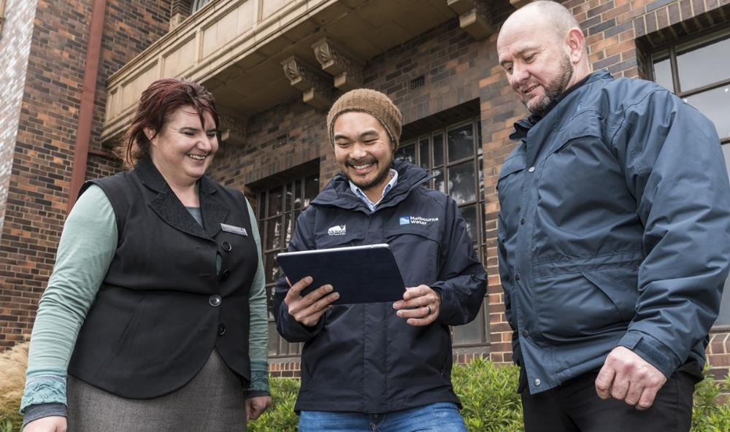

Achievements to date

Melbourne Water’s 2016–2020 Diversity and Inclusion Strategy
Implementation of Melbourne Water’s first Diversity and Inclusion Strategy (2016–2020) focussed on the areas of: flexible working, gender equity, accessibility (disability), and reconciliation.
The initiatives delivered over the last 5 years have resulted in significant change in relation to Melbourne Water’s workforce composition and workplace culture. Melbourne Water has taken a best-practice proactive approach to deliver against the 2016–2020 Diversity and Inclusion Strategy (see the appendix for highlights).
Data suggests that both workforce diversity and indicators of an inclusive workplace culture have realised strong growth over the last 5 years. This data is summarised below.

Workforce diversity
Melbourne Water has increased representation of women (32.8% June 2016 to 37.4% June 2019), Aboriginal and Torres Strait Islanders (0.4% June 2016 to 1.4% June 2019), people with disability (1.9% June 2016 to 7.7% June 2019), and members of the LGBTIQ+ community (3.2% June 2018 to 4.1% June 2019). A yearly breakdown of figures can be found in the appendix.

Inclusive workplace culture
Cultural indicators of inclusion have also been tracked over the last 5 years, and demonstrate strong improvements in employees’ perspectives of the level of inclusion at Melbourne Water. In particular, Melbourne Water has made significant gains in the areas of flexible working, leadership commitment, and employees’ awareness of the business advantages of diversity and inclusion.

Challenges and risks
Melbourne Water has had ambitious targets, particularly in relation to gender, people with disability, and Aboriginal and Torres Strait Islander representation. While achieving these targets has proven a challenge, we have learned from previous initiatives that guide the delivery of this strategy through a focus on multiple areas of diversity, and our continued commitment to making steady progress. We recognise that growth in demographic diversity must be considered alongside the readiness of the organisational and team culture to include individuals from diverse backgrounds. Steady growth of diversity with targeted support has been key over the last 5 years.
The 2020–2025 Diversity and Inclusion Strategy
The Diversity and Inclusion Strategy (2020–2025) outlines the vision, framework and areas of focus for Melbourne Water to continue our commitment towards building a diverse and inclusive environment for our people, stakeholders and community. This strategy is underpinned by existing detailed action plans in the areas of flexible working, gender equity, accessibility (disability) and reconciliation. Action plans will be developed to provide support and opportunities for Culturally and Linguistically Diverse communities, and those from Socially Disadvantaged backgrounds.
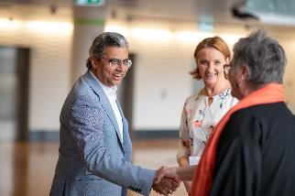

Who does this strategy apply to?
This strategy applies to all Melbourne Water employees, including permanent and casual employees. In addition, many elements of the strategy also apply to our contractors, stakeholders, customers, and the broader community.

How was this strategy developed?
The Diversity and Inclusion Strategy (2020–2025) was developed through extensive consultations with employees and external stakeholders, including a survey, workshops, meetings and interviews. Further detail on this process is included within the appendix under Methodology.

Strategic Vision
Melbourne Water aspires to achieve a truly inclusive workplace culture, characterised by all employees demonstrating respect and value for diversity, including backgrounds, perspectives, skillsets and contributions. We are committed to ensuring that we attract and retain people from diverse backgrounds, and provide opportunities to all Melbourne Water employees, regardless of their individual characteristics. Through building our inclusive workplace culture, identifying and removing barriers to participation, and providing opportunities to individuals and groups who experience significant barriers to employment, we will grow the diversity of our workforce.
The Strategic Framework that shows how Melbourne Water will deliver on this vision is on the next page, followed by a Strategic and Legislative Alignment diagram, demonstrating how the Diversity and Inclusion Strategy is aligned with and empowers the delivery of other Melbourne Water strategies, legislation and goals

Strategic Framework

Diversity & Inclusion Vision

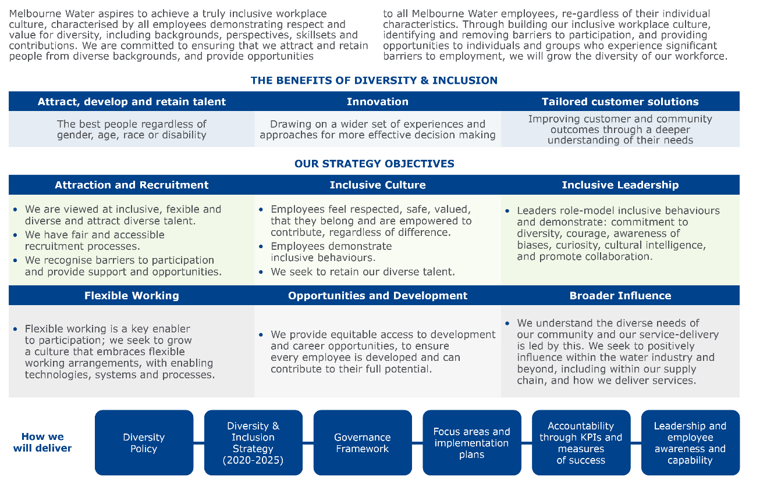

Strategic and Legislative Alignment
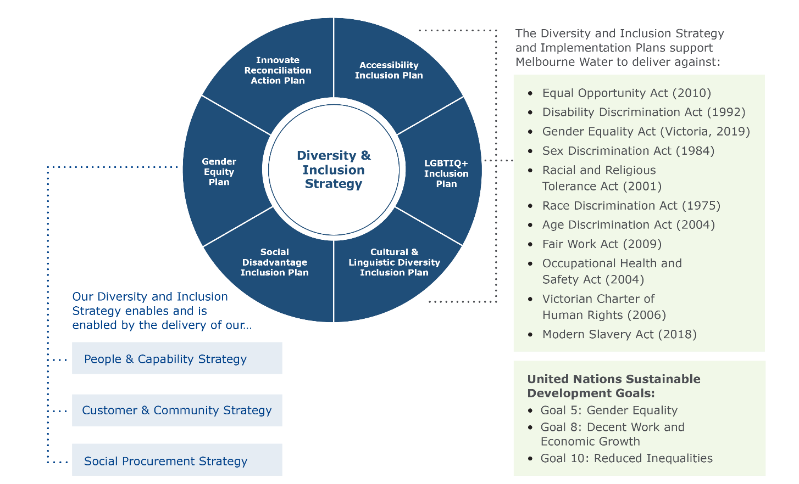

Diversity and Inclusion Strategy Objectives and Outcomes
The following Objectives and Outcomes will guide the steps we will take to achieve our Diversity and Inclusion Strategy (2020–2025).
Specific targets are set for a number of these measures annually, through the action plans that underpin the Strategy. Other measures and targets will be set when baseline data is established in 2020 and will be reported through annual governance processes.
Objective | Outcomes | Key Measures
Attraction and Recruitment  We are an organisation with a clear employee-value proposition that is viewed as inclusive, flexible and diverse; we attract diverse talent to all roles and business groups. We provide recruitment processes that are accessible, are fair and enable selection based on skills, capability, and team and organisational needs. We recognise the additional barriers some groups experience and provide support and opportunities to create a more equitable recruitment process. | We attract individuals from diverse demographics (including gender, age, race, LGBTIQ+, Aboriginal and Torres Strait Islanders) and functions (roles, industries) to apply for roles at Melbourne Water.  The community views Melbourne Water as a diverse, inclusive, and flexible organisation.  Diversity, inclusion, and flexibility will be recognised as key elements of our employee-value proposition.  We understand biases within the selection process (attraction, recruitment), and develop actions and processes to mitigate these.  Demonstration of inclusive behaviours and ability to work with diverse teams are key selection criteria, and the existing diversity of the team and business group is considered as an element in making recruitment decisions.  We create programs and alternative pathways to employment for identified groups who experience significant barriers to workforce participation.  We are flexible in our recruitment process to support and meet individual needs (e.g. reasonable adjustments), ensuring an equitable recruitment process. | - Increase in % of applicants who are: people with disability, men and women (for male/female-dominated roles), Aboriginal and Torres Strait Islanders, of various age ranges (younger and mature workers), and from CALD backgrounds.  - Questions integrated into the Customer Reputation Survey from 2020/21 to establish a baseline understanding; increase in positive customer feedback regarding Diversity and Inclusion at Melbourne Water.  - Proportion of shortlists that have gender-balance.  - Gender balance and diversity of graduate and scholarship recipients, internships and traineeships, talent and development opportunities.  - Specific programs for disability, social disadvantage and CALD, that contribute to an increased representation of demographic diversity.  - Applicants with disability report a positive recruitment process.
Inclusive Culture  Our culture is characterised by respect and safety. Employees demonstrate inclusive behaviours, and employees feel they are respected, valued, belong and are empowered to contribute, regardless of individual differences. We actively seek to retain our diverse talent. | Employees understand and demonstrate appropriate workplace behaviours.  There is a fair and accessible process to manage inappropriate workplace behaviours.  Employees develop skills to work with individuals from diverse backgrounds.  Employees develop awareness of others’ experiences, demonstrating curiosity and an openness to learning.  All employees feel they belong and are empowered to contribute.  Employees and leaders increase their understanding of unconscious bias, its impacts at work and how they can amend their behaviour to manage biases. | - Survey data (with comparisons for diverse groups):  - Increased positive responses to the following:  At Melbourne Water, engaging in improper conduct (i.e. bullying, sexual harassment) is not tolerated.  The business advantages of diversity and inclusion have been clearly communicated to me.  I have a strong sense of belonging to Melbourne Water.  - Employees report an understanding of appropriate behaviours and sexual harassment, bullying and discrimination.  - Employee feedback demonstrates that employees perceive the complaints process to be fair and accessible.  - Incidence and resolution rates of discrimination / harassment complaints by diverse groups.  - Identify, address and report on pay gaps.  - Increased % of employees who have attended Cultural Awareness training.  - Increased % of employees who have completed the following e-learning:  Introduction to Diversity and Inclusion  Family Violence  Accessibility Inclusion  First Nations Cultural Awareness
Inclusive Leadership  Leaders role-model inclusive behaviours, and demonstrate commitment to diversity, courage, awareness of biases, curiosity, cultural intelligence, and collaboration. | Leaders role-model flexible working.  Leaders demonstrate awareness of their own biases and support changes to behaviours and systems to promote fairness.  Leaders demonstrate an understanding of why Melbourne Water embraces diversity and inclusion, and actively champion diversity and inclusion initiatives.  Leaders demonstrate curiosity and seek to understand the individual strengths of their team members.  Leaders seek to increase their knowledge of and capability to work with diverse groups.  Leaders foster collaboration through creating team environments where diverse perspectives are encouraged and captured. | - Survey data:  - Increased positive responses to the following:  Melbourne Water’s leadership team are committed to diversity.  My leader understands, champions and sponsors diversity and inclusion initiatives.  The business advantages of diversity and inclusion have been clearly communicated to me.  - Team members report high levels of inclusion.  - Increase in leaders sharing stories (increased number of stories via internal communications).  - Increased leadership engagement in programs that support diversity and inclusion.  - Leadership performance assessed against progress towards diversity targets and delivery of actions within implementation plans.
Flexible Working  Flexible working is a key enabler to participation; we seek to grow a culture that embraces flexible working arrangements, with enabling technologies, systems and processes. | Melbourne Water continues to innovate to provide flexible working options across all areas and roles.  People & Capability provides structural support and advice to enable employees to work flexibly (e.g. job re-design for part time roles).  Working flexibly is not seen as a barrier to career progression; there are visible examples of managers working flexibly (including in part time and job share capacities). | - Uptake in a range of informal and formal flexible working across Melbourne Water, at all levels, roles and across diverse groups.  - % of employees in operational roles accessing flexible working arrangements.  - % of employees in leadership roles accessing flexible working arrangements.  - Increased manager agreement that the process of setting up and managing formal flexible working arrangements (including part time roles and job share) is accessible and easy to manage.  - Increased number of men working flexibly (total formal and informal).  - Survey data – increased positive responses to the following:  Melbourne Water helps me to achieve the ideal work/life balance.  Melbourne Water supports flexible work arrangements.  Employees can advance their careers at the same time as using flexible work arrangements.
Development  We provide equitable access to development and career opportunities, to ensure every employee is developed and can contribute to their full potential. | Diverse employee groups progress at the same rate as others and we seek to understand underlying barriers and biases to secondment opportunities and promotions, and develop actions and processes to mitigate these.  Contributions to diversity and inclusion initiatives are recognised as valuable and contribute to employees’ and leaders’ performance assessments.  We identify gaps in development opportunities for diverse groups and rectify these.  We identify high rates of turnover and seek to retain talented staff.  We deliver specific programs to create equitable pathways to leadership and skill development.  Demonstration of inclusive leadership behaviours and ability to work with diverse groups is a key criteria when making decisions regarding career progression (e.g. secondments and promotions). | - Survey data: increased positive response to the statement ‘Our culture ensures that every talented person has an equal opportunity to reach a senior leadership position’.  - Exits and turnover for high-performing employees and diverse employees monitored.  - Return rates and retention rates for employees 12 and 18 months post parental leave.  - Secondment, acting and promotion rates for diverse talent.  - Performance and talent mapping by gender and diverse talent.  - Gender and diverse talent representation in development programs.  - Gender pay gap analyses reveal no gender pay gap (if pay gaps are identified, these are rectified and systems amended).
External influence  We understand the diverse needs of our community and seek to positively influence within the water industry and beyond, including within our supply chain. | We understand the diverse needs of our community and creative inclusive and accessible methods of communication and consultation.  We share successful initiatives with the water sector and beyond.  We positively influence our supply chain through integrating diversity, accessibility, and inclusion goals and measures in contracts and tender criteria. | - % of tenders with questions relating to diversity and inclusion.  - Number of external stories shared (e.g. on social media).
Note: Many of the measures of success are reflective of the actions set out in the diversity and inclusion plans including the Gender Equity Plan (2018–2020) Accessibility Inclusion Plan (2018–2021), and Reconciliation Action Plan (2018–2020). Some of these measures will also be reflected in the CALD and Social Disadvantage plans to be developed
in 2020.
To effectively track recruitment, retention, development and promotion of all diverse groups, it will be necessary
to host this data in the HR Information System. Providing personal data will be optional, and employees will have opportunity to provide this at the hiring/on-boarding stage and during their employment. An upgrade of the
current system will be required to enable employees to update their individual employee profile data.

From Vision to Action – implementing the strategy

Implementation Approach and Governance Framework
Supporting the execution of the Diversity and Inclusion Strategy is the following Governance Framework.
Group | Responsibilities
Managing Director/  Board / People Safety Remuneration Committee | Managing Director Approves Diversity & Inclusion Strategy and underpinning action plans  PSRC endorse and have oversight of the Diversity and Inclusion Strategy  PSRC to review progress on a quarterly basis, through the Quarterly People Insights report  PSRC receives strategy progress update annually and reports to the Board
Leadership Team | Accountable for delivery and ownership of the Diversity and Inclusion Strategy  Review progress on a (minimum) quarterly basis  Demonstrate commitment, deliver agreed actions within implementation plans, and role-model behaviours to support delivery of the strategy
Diversity and Inclusion Steering Committee | Monitor the implementation of the Diversity and Inclusion Strategy, and implementation plans, including reviewing and endorsing KPIs and associated implementation plans (after they are developed by the Diversity and Inclusion team)  Review progress quarterly (at a minimum)  Advocate and champion diversity and inclusion initiatives
Diversity and Inclusion Working Groups | A member of the Senior Leadership Team sponsors and chairs each working group for all key priority areas including gender, Accessibility, LGBTIQ+, Cultural and Linguistic Diversity, Reconciliation, and Social Disadvantage.  Working groups are responsible for supporting the development and delivery of an implementation plan within their area of focus (for example, Accessibility Inclusion).  The Sponsor of the Working Group will report progress to the Diversity Inclusion Steering Committee (DISC) quarterly.
Diversity and Inclusion Team | Provide subject matter expertise to guide the business in delivering the Diversity and Inclusion Strategy and manage relationships with external advisory services and service providers (for example, the Australian Network on Disability).  A minimum of one member of the team will attend working group meetings, and the team will attend DISC meetings and provide secretarial support.  Monitor and report on the implementation of the Diversity and Inclusion Strategy, and implementation plans.  Guide the development of implementation plans, including proposing/setting appropriate KPIs.  Lead key projects and guide the delivery of implementation plans through the provision of project management and expert advice, to encourage an enterprise effort.

Review
The Diversity and Inclusion Strategy will be reviewed each year to ensure that it remains relevant for the organisation, which will in turn result in the plans for Accessibility, Gender, Reconciliation and other areas of focus being reviewed and updated accordingly.

Appendix

Legislative and policy requirements
Melbourne Water’s Diversity and Inclusion Strategy (2020–2025) will adhere to the following legislative and policy requirements.

Commonwealth legislation
Age Discrimination Act 2004 makes it lawful that Australians of all ages have a right to be treated fairly and have the same opportunities as everyone else.
Australian Human Rights Commission Act 1986 provides for the rights of people with physical or mental disabilities and addresses complaints of discrimination in employment.
Disability Discrimination Act 1992 provides protection for everyone in Australia against discrimination based on disability. The DDA makes it unlawful to discriminate in the provision of goods, services or facilities against people on the basis that they have, or may have, disability. It is also unlawful to discriminate on the basis that a person has or may have associates with disability.
Fair Work Act 2009 provides a balanced framework for cooperative and productive workplace relations that promote national economic prosperity and social inclusion for all Australians.
Racial Discrimination Act 1975 makes it unlawful to discriminate in employment on the grounds of race, colour or national or ethnic origin.
Sex Discrimination Act 1984 makes it unlawful to discriminate in employment on the grounds of a person’s sex, marital status, pregnancy or potential pregnancy, or to sexually harass another person.

Victorian legislation
Charter of Human Rights and Responsibilities Act 2006 sets out our freedoms, rights and responsibilities. This formal recognition of our human rights protects people from injustice and allows everyone to participate in and contribute to society.
The Gender Equality Act 2019 requires all public sector entities to develop a gender equality plan, and every two years, report against measurable targets and quotas, the gender pay gap, sexual harassment and achieving equality in career opportunities.
Disability Act 2006 requires that all public sector bodies must have a Disability Action Plan and provides for a strong whole of government, whole of community response to the rights and needs of people with disability. The Disability Act 2006 established a framework for the provision of high-quality services and supports for people with disability. It also established the Disability Services Commissioner, who provides a free and accessible process for resolving complaints.
Equal Opportunity Act 2010 makes it unlawful to discriminate in employment on the basis of a number of personal characteristics.
Multicultural Victoria Act 2011 establishes a number of important principles of multiculturalism; it strengthens the Victorian Multicultural Commission and establishes reporting requirements for government departments in relation to multicultural affairs.
Under the Occupational Health and Safety Act 2004 all employers must maintain a secure, healthy and safe working environment.
Racial and Religious Tolerance Act 2001 aims to promote racial and religious tolerance by prohibiting certain conduct involving the vilification of persons on the ground of race or religious belief or activity and provides a means of redress for the victims of racial or religious vilification.
Public Administration Act 2004 provides a framework for good governance in the Victorian public sector and in public administration generally in Victoria.
Carer Recognition Act 2012 provides a framework for the Victorian public sector to increase recognition and awareness of the role carers play in providing daily care and support to people with disabilities, medical conditions, mental illness or who are frail aged.

International conventions
United Nations Convention on the Rights of Persons with Disabilities
United Nations Sustainable Development Goals – Melbourne Water is a signatory to these goals.

Melbourne Water’s Approach to Diversity
and Inclusion

Intersectionality defined
Individuals are inherently multi-faceted – both in terms of their status(es) within different communities (for example, with respect to culture/race, disability status, or other factors) and a wide range of other important attributes (for example, level of education, relative opportunities, and so on).
The term intersectionality refers to the interaction between different aspects of our identities and can assist to understand how people’s experiences are shaped by (but not limited to) their race, socio-economic background, sex, gender, age, and sexuality (etc.) all at the same time. This overlap or combination of differences makes up a person’s unique identity.
The point of intersectionality is to understand the variety of privileges or
forms of discrimination, disadvantage or exclusion that one may potentially experience simultaneously at any given time (for example, gender and
race together).

Social Disadvantage defined
Social Disadvantage arises as a result of an interaction of life experiences, circumstances and identities. The Victorian Government’s Social Procurement Framework defines Disadvantaged Victorians as “Victorian people or groups that are in unfavourable circumstances or considered to be vulnerable, especially in relation to financial, employment or social opportunities. This may include, but is not limited to, youth, long-term unemployed, people with disability, refugees, migrants and persons needing to develop skills to become work ready”.
A number of Melbourne Water’s focus areas capture initiatives to support communities that often experience social disadvantage, for example:
- People with disability experience significant barriers to participation within employment in Australia. Compared with other OECD nations, the participation of people with disability within employment in Australia is very low. Discrimination on the basis of disability remains the most prevalent complaint made to the Australian Human Rights Commission. Addressing barriers and creating employment opportunities are key aspects of Melbourne Water’s Accessibility Inclusion Plan (2018–2021).
- New migrants experience barriers to employment, and Culturally and Linguistically Diverse community members (even those born in Australia) can experience discrimination and biases when seeking and participating in employment. While Melbourne Water does not yet have a targeted plan on CALD employment, we have recently commenced the Pathways Program, providing a group of skilled migrants with vital work experience in their field of expertise.
- People experiencing family violence are at high risk of experiencing social disadvantage. Melbourne Water provides paid family violence leave and other supports can be put in place through our Family Violence Safety Plan. These actions are captured within our Gender Equity Plan (2018–2020).

Melbourne Water’s Diversity and Inclusion Journey

Highlights
- Strong employee and leadership engagement and involvement through working groups, employee networks (for example, Refract, Kaleidoscope) and embedding actions across the business
- The establishment of a best-practice governance structure
- Development and delivery of plans related to the strategy, including Gender Equity Plans, Accessibility Inclusion, Reconciliation, Flexible Working, and LGBTIQ+ Inclusion
- Increased uptake of flexible working, and flexible working recognised as a key element of Melbourne Water’s employee-value proposition
- Building managers’ skills to manage diverse teams through Inclusive Leadership training
- Improving the experience of employees taking parental leave through our Keeping in Touch Program. The program was expanded in 2018 to include access to coaching and a business update delivered by the MD and leadership team. These changes have delivered improved engagement and retention of employees returning from parental leave.
- Training and procedures to support employees experiencing family/domestic violence
- Increased cultural awareness and engagement with the Victorian Aboriginal and Torres Strait Islander community
- Providing opportunities to talented migrants from diverse cultural backgrounds through the Pathways Program
- Building disability confidence and providing opportunities to people with disability through PACE Mentoring and Stepping Into Internships

Workforce diversity
The table below demonstrates the growth Melbourne Water has achieved in demographic diversity: increasing the representation of Aboriginal and Torres Strait Islanders, the LGBTIQ+ community, people with disability, and people from Culturally and Linguistically Diverse backgrounds, in addition to creating a more gender-balanced workforce.
Targets | Baseline representation | Representation at June 2019
% Overall workforce female (40% by 2023) | 32.8% (June 2016) | 37.4%
% Leaders* female (40% by 2023) | 39.3% (June 2017) | 43.5%
% Service Delivery (SD) workforce female (30% by 2023) | 23.5% (June 2016) | 27.5%
% SD leaders female (30% by 2023) | 22.2% (June 2017) | 16.7%
% Corporate workforce female (40–60% by 2023) | 48% (June 2016) | 51.2%
% Corporate leaders female (40–60% by 2023) | 46.5% (June 2017) | 54.5%
3% of our workforce will identify as Aboriginal or Torres Strait Islander | 0.4% (June 2016) | 1.4%
12% of our workforce will identify as having a disability | 1.9% (June 2016) | 7.7%
Culturally and Linguistically Diverse | 22.4% born overseas (June 2018)  6.8% speak a language other than English at home | 25% born overseas  8.7% speak a language other than English at home
LGBTIQ+ | 3.2% (June 2018) | 4.1%

Figure D: Melbourne Water’s growth in demographic diversity

* Leaders are defined as MD, LT and DR

Inclusive workplace culture
Cultural indicators of inclusion have also been tracked over the last 5 years through annual surveys, and demonstrate strong improvements in employees’ perspectives of the level of inclusion at Melbourne Water. In particular, Melbourne Water has made progress on uptake of informal and formal flexible working arrangements, and employees’ perspectives on the level to which flexible working is accepted and embraced.

Survey Statements | % of favourable responses (agree/strongly agree) to survey statement
 | 2015 | 2016 | 2017 | 2018 | 2019
Melbourne Water capitalises on the potential of all employees regardless of gender, ethnicity or disability | 47% | 52% | 54% | 62% | -
MW helps me to achieve the ideal work/life balance | 43% | 59% | 62% | 67% | -
I have a strong sense of belonging to Melbourne Water | 49% | 59% | 62% | 69% | -
MW’s leadership team are committed to diversity | 42% | 47% | 71% | 76% | 82%
The business advantages of diversity and inclusion have been clearly communicated to me | 42% | 48% | 62% | 71% | 83%
Employees can advance their careers at the same time as using flexible work arrangements | 36% | 35% | 58% | 62% | 63%
Our culture ensures that every talented person has an equal opportunity to reach a senior leadership position | 27% | 30% | 33% | 38% | -
MW supports flexible work arrangements | - | - | 78% | 80% | 80%
I utilise formal flexible working arrangements | - | - | 19% | 27% | 29%
I utilise informal flexible working arrangements | - | - | 76% | 66% | 74%
Figure E: Melbourne Water’s growth in indicators of an inclusive workplace culture

Methodology
The Diversity and Inclusion Strategy development process provided a unique opportunity to engage with our diverse workforce and relevant external stakeholders to develop Melbourne Water’s future vision and identify potential barriers to success.
In addition, the Diversity and Inclusion team reviewed the latest research and leading-practice diversity and inclusion strategies from both the private and public sector, along with relevant legislation and goals. Research and external consultations highlighted that while inclusion is key to capitalising on diversity of thought and experience, workforce diversity cannot be achieved without a continued focus on key groups that experience barriers to participation.

Consultations – key insights
Melbourne Water’s Managing Director encouraged all staff to engage in consultations: 43% of employees participated in an internal survey, and 4 workshops were held across sites to provide employees with the opportunity to guide the future vision for Diversity and Inclusion at Melbourne Water.
This consultative approach has provided insights into our existing state and how Melbourne Water could progress along the maturity scale. An organisation’s maturity in embedding diversity and inclusion can be described across 5 levels, as shown in the figure below. Most employees describe Melbourne Water’s maturity in relation to Diversity and Inclusion as Level 3 Committed and Reflective. At a level 3 maturity, employees view diversity and inclusion as a key value at Melbourne Water; difference is accepted, and employees see the benefits of diversity and inclusion to both them and the organisation.
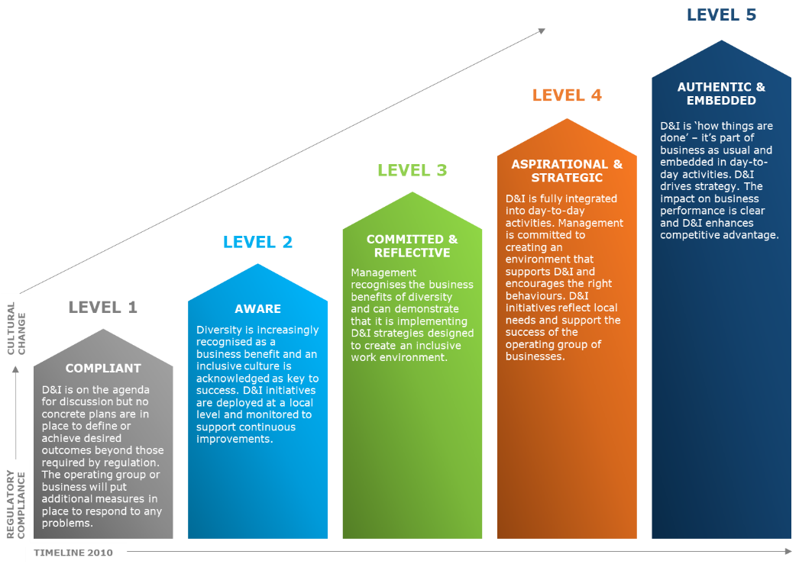
The graph below demonstrates employees’ perceptions of Melbourne Water’s diversity and inclusion maturity (separately), according to 5 levels:

Figure G: Employees’ perceptions of D&I Maturity at Melbourne Water
Internal consultations revealed that flexible working, LGBTIQ+ inclusion, support for gender equity, our Keeping in Touch Program (for employees on parental leave), awareness of the benefits of diversity, and leadership support are key areas of strength at Melbourne Water. These were key focus areas within the 2016–2020 Diversity and Inclusion Strategy, highlighting the visible strides Melbourne Water has made.
Key areas for improvement include considering improvements in attraction and selection processes, creating culturally safe work environments, and a greater focus on Cultural and Linguistic Diversity and Social Disadvantage (new areas of focus within the 2020–2025 Diversity and Inclusion Strategy). We continue to have work to do to ensure leaders role-model inclusion (e.g. flexible working) and ensuring our internal systems and external services are truly accessible for people with disability.

Internal consultations included:
- An internal survey: Melbourne Water employees were encouraged to complete the ‘Have your say – Diversity and Inclusion’ survey, with 524 (44%) employees responding. The survey provided insight into employees’ perspectives on the current state and desired future vision for Diversity and Inclusion. Melbourne Water’s Diversity and Inclusion team developed the survey and analysed the results.
- Four strategy development workshops: held at Docklands, Winneke, Eastern Treatment Plant and Brooklyn, provided the opportunity for diverse groups of employees to share their perspectives and guide the development of the strategy. Consultants from Whereto Research facilitated the workshops to encourage honest feedback.
- Meetings with internal stakeholders: all Melbourne Water employees had the option to have a phone or face-to-face meeting with consultants from Whereto Research. Interviews were conducted with twelve employees, including several senior leaders. The Diversity and Inclusion team also held meetings with identified internal stakeholders.

External consultations included:
- Meetings with external stakeholders: external stakeholders were engaged through meetings with a member of the Diversity and Inclusion team, including representatives of the Australian Network on Disability, Diversity Council of Australia, and Australian Intercultural Society.
- These consultations revealed that in many ways Melbourne Water is considered to be adopting leading practice, for example the utilisation of internal networks, and strong and active leadership. Consultations also highlighted that the future of Diversity and Inclusion is shifting to organisations having a dual internal and external focus.

Future trends
The Diversity and Inclusion Strategy was developed against the backdrop of a changing social landscape, and its implementation will need to consider several factors. These include:
- Changes to the Australian family model, with an increasing number of dual-income households and singles. While women still complete the majority of unpaid care and household work, men are increasingly taking up greater care responsibilities and parental leave. However, both men and women continue to report experiencing levels of discrimination when taking leave and returning to work.
- Gone are the days when organisations separated themselves from societal issues; with changing attitudes and expectations of organisations from community, organisations are expected to support diverse communities and consider their corporate social responsibilities; a key area of untapped opportunity for Melbourne Water.
- Changing workforce demographics: by 2025, GenX and Millennials will comprise 64% of the working population. These demographics have different expectations: seeking flexibility and autonomy in their work, and opportunities for career progression. Younger generations will have multiple careers, and organisations will need to adapt to manage changes in personnel, becoming less reliant on work done through the strength of relationships and more reliant on inclusive and enabling processes. The world’s population is also ageing rapidly; in 2050, those aged 65 and over will reach 22% of the global population (up from 10% today).
- Australia is becoming an increasingly multicultural society, with increased immigration from regions including Africa and the Middle East over the last 10 to 15 years. Climate refugees will likely be part of a future wave of migrants.
- Against the backdrop of the #MeToo and #TimesUp movements, there are changing expectations of gender, including challenges to what Australian society has typically perceived as ‘masculine’ and ‘feminine’. This can provide an opportunity for organisations like Melbourne Water, who can play a role in challenging stereotypical views on job roles for men and women. Through increased awareness of sexual harassment at work, there has been a general societal shift with less tolerance for poor behaviours, and an increasing expectation for employers to take a proactive approach to creating a safe work environment.
- Increases in artificial intelligence must also be considered. As we adopt more of these technologies and seek to automate our systems, we must consider how inclusive and accessible these systems are.

References
The following papers and information sources were used in developing the strategy:
ABS 2016 Census data
ABS 443.0 – Disability, Ageing and Carers, Australia: Summary of Findings, 2018
Australian Human Rights Commission. (2015). Face the facts: Lesbian, Gay, Bisexual, Trans and Intersex People https://www.humanrights.gov.au/our-work/education/face-facts-lesbian-gay-bisexual-trans-and-intersex-people
Biddison, E. L. D., Paine, L., Murakami, P., Herzke, C., & Weaver, S. J. (2016). Associations between safety culture and employee engagement over time: a retrospective analysis. BMJ quality & safety, 25(1), 31-37.
Bourke, J. (2016). Which Two Heads are Better Than One?: How Diverse Teams Create Breakthrough Ideas and Make Smarter Decisions. Australian Institute of Company Directors.
Bourke, J., & Dillon, B. (2016). The six signature traits of inclusive leadership. Deloitte Insights.
Diversity Council Australia (O’Leary, J and D’Almada-Remedios, R.). (2019). DCA-Suncorp Inclusion@Work Index 2019-2020: Mapping the State of Inclusion in the Australian Workforce, Sydney, Diversity Council Australia.
Department of Premier and Cabinet Victoria and The Centre for Ethical Leadership, University of Melbourne. (2018). Recruit Smarter: Report of Findings.
Mor Barak, M. E. (2000). The inclusive workplace: An ecosystems approach to diversity management. Social work, 45(4), 339-353.

